**Bus ticket booking**

# **About Abibus**

Abhibus is an online platform for booking bus tickets in India. It offers a wide range of bus operators and routes, with real-time updates on schedules, availability, and fares.

## **Purpose of the document**

The purpose of the document is to book bus ticket from Bangalore to Mysore.

### **Instructions**

* Open web browser, enter <https://www.abhibus.com/> in address box
* Enter Bangalore in **Leaving from** box, and Mysore in **Going to** box
* Click calendar icon, and then select **Date of journey** Refer Figure 1

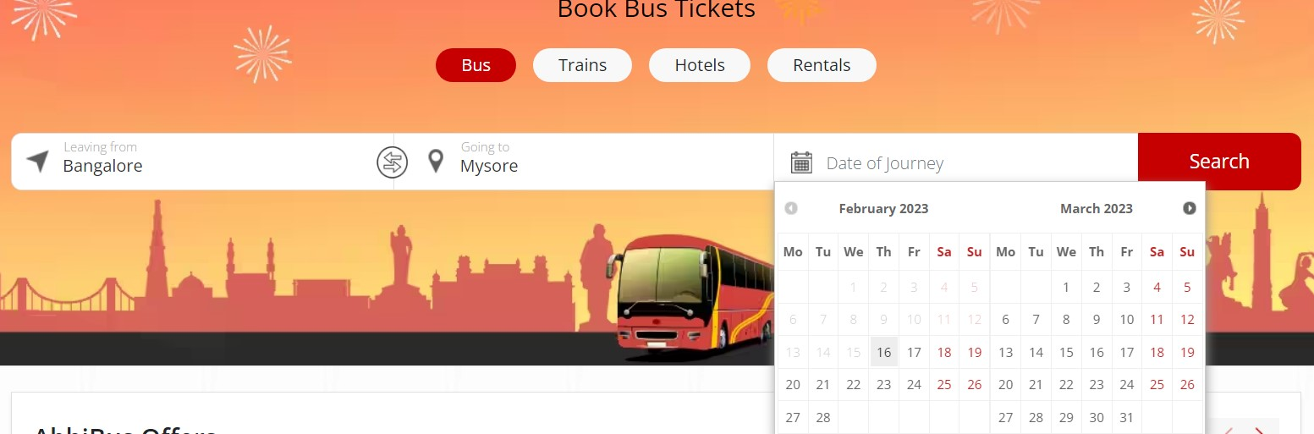

Figure

* Click the **Search** button
* Click the **Select seats** button in available bus options
* Select a seat that is **Available** Refer Figure 2

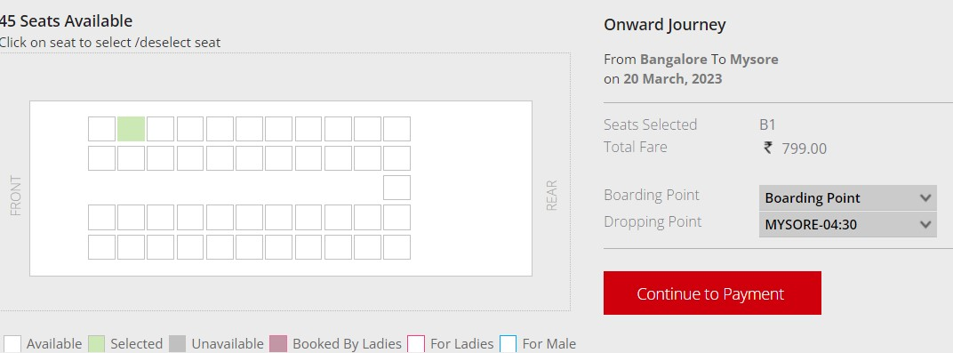

Figure

* Click **Boarding Point** drop-down, and select location
* Click the **Continue to Payment** button
* Enter mobile number in **Enter Mobile Number** box, and click the **Send OTP** button or
* Sign in using email account
* Enter OTP in **OTP** box, and click the **Verify** button Refer Figure 3

***Note****: One-time password (OTP)*

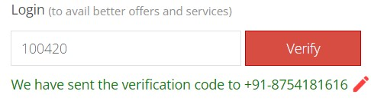

Figure

* Enter Email ID in **Enter your** **Email ID** box
* Enter full name in **Enter Full Name** box, and then age in **Age** box
* Click **Save passenger list** option
* Select the **Pay Now** button
* Click the **Show code** button to scan, and then pay via Phonepe or
* Enter mobile number in **Enter your mobile number** box, and then click the **Send OTP** button Refer Figure 4

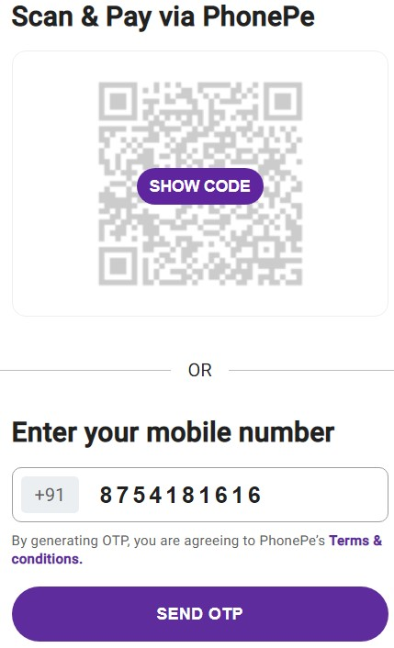

Figure

* Enter 5-digit OTP sent, and then click the **Register** button
* Enter card number in **Card number** box
* Enter month and year in **Valid till** box
* Enter CVV number in **CVV** box
* Click the **Pay** button
* Check email to see booked tickets